Bodycoats Road
Toynbee School
Chandlers Ford
Eastleigh
Hampshire
S053 2PL

Appointment
of Minibus Driver

Contact Details:

Tel: 023 80269026
Email: recruitment@toynbee.hants.sch.uk
Website: www.toynbee.hants.sch.uk/recruitment

APPLICATION DETAILS

I have enclosed with this pack the following details:

- Job description
- The Senior Leadership Team structure
- A letter from the Headteacher

An application form (support staff) is available to download from Toynbee School website. See link: www.toynbee.hants.sch.uk/recruitment

Employment Checks

Employment checks will be undertaken to establish positive outcomes in the following areas dependent upon role:

- Personal Identity
- Right to Work in the UK
- Police check/Enhanced Level Disclosure and Barring Service Check (previously CRB disclosure)
- Employment History
- Qualifications
- Health
- References

Equal Opportunities Statement

In our school we are committed to securing genuine equality of opportunity, whether required by law or not, in all aspects of our activities as an employer and service provider.

This commitment is based on our belief in the broad principles of social justice and our aim is to provide services and employment on a fair and equitable basis.

Our staff are encouraged to demonstrate their commitment to equality by taking active steps to: eliminate discrimination, promote equality of opportunity and promote good race relations.

Toynbee School Job Description

Post | Minibus Driver | Current  Post Holder | New Post
Allowance/  Scale | EHCC Grade B | Date Reviewed
Reports to | Senior Site Manager | Signed

Accountability:
The Minibus Driver will be responsible to the Senior Site Manager

Section B

Organisation

Headteacher

Bursar

Senior Site Manager

Site Manager
Site Assistant

Minibus Driver
Contract Cleaning
Site Assistant

Section B

ROLE REQUIREMENTS

This involves identifying the most significant responsibilities of the role. Accountability statements are key functions of the role which in combination make up the main purpose.

 |  | % of
Accountabilities | Accountability Statements | Time
Transport | • To drive the vehicle safely and within the law and | 65%
 | Highway Code.
 | • To have regard at all times for the safety of
 | passengers, ensuring seatbelts are worn where
 | fitted and other equipment is applied correctly and
 | appropriately
 | • To be courteous at all times to passengers, other
 | road users and pedestrians.
 | • To assist passengers in boarding and alighting
 | and to assist an escort where necessary
Planning | • To plan routes with due regard to safety, time and | 5%
 | economy as required, ensuring the route is the
 | quickest and most effective
Maintenance | • To ensure the vehicle is adequately fuelled and for | 15%
 | long school trips, make fuel stops regularly so that
 | the minibus never runs out of fuel
 | • To report any defects immediately to the
 | headteacher so that they are rectified
 | • To take the vehicle to be serviced and have its
 | MOT as required, meeting legal and LEA
 | requirements
 | • Carry out minor maintenance and daily vehicle
 | checks including:
 | o External damage to vehicle
 | o Tyre conditions and pressures
 | o Oil, water, brake fluid and fuel levels
 | o Lights and indicators are clean and in
 | working order
 | o Washers and wipers are working
 | o Horn is working
 | o Mirrors are intact, clean and correctly
 | positioned
 | o Seat belts, where fitted are working properly
 | o Fire extinguisher is intact and first aid kit is
 | complete

Health and Safety | • A strict policy of no smoking will be adhered to at | 5%
 | all times
 | • Drivers must not drink alcohol whilst on duty and
 | are to be within the legal limit to drive
 | • Drivers must not allow any person to drive or travel
 | on the vehicle without the permission of the
 | headteacher
 | • All accidents must be reported immediately to the
 | police and headteacher
 | • Any injury to self, passengers, pupils or the general
 | public must be reported immediately using
 | appropriate channels (depending on the severity of
 | the injury)
Administration | • To complete all forms relating to mileage and other | 5%
 | aspects of vehicle maintenance as required.
Corporate and | • Apply and enforce all HCC guidelines and statutory | 5%
statutory initiatives - | obligations in these areas to ensure compliance
equalities/health | • Identify and offer to the team all suitable training
and safety/e- | • Identify and offer to the team all suitable training
government/ | and development opportunities in these areas
sustainability

Section D -The key decision making areas in the role

- Deciding on appropriate routes for daily pupil-runs and on long distance school trips

- Vehicle maintenance decisions

Section E - The role dimensions - financial (e.g. budgets) and non-financial (e.g. units, workload, customers/staff)

- Planning the most effective route will save on fuel costs

- Reporting defects at an early stage may save on larger repair bills

- Responsibility for maximum of x pupils on the minibus

- Approximate miles per year: x miles

Section F - The main contacts – external/internal customer contacts and purpose

- Parents, when picking up and dropping off children

- Teachers/ teaching assistants when dropping off and picking up children from school

- External contractors, with regards to maintenance

26.07.06

HAMPSHIRE COUNTY COUNCIL
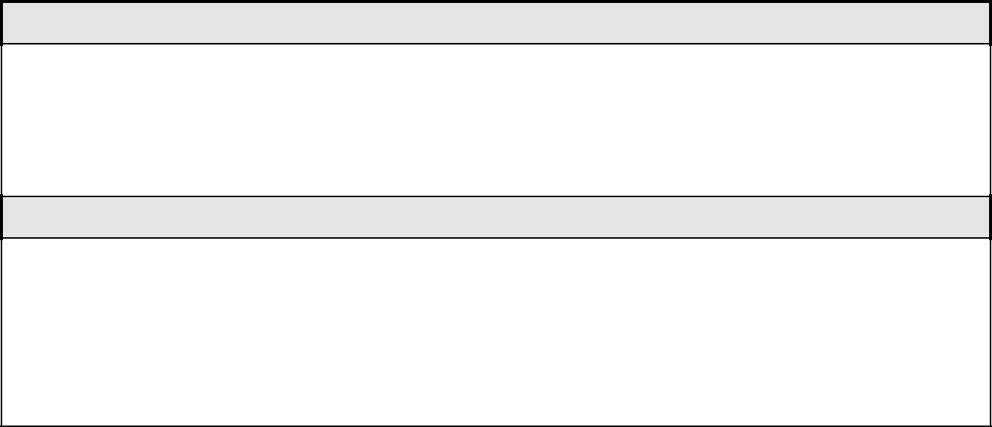

Section G - Working conditions – environment, and physical effort or strain.

- Some pupils will require assistance in getting on and off the bus, due to physical difficulties. This can be physically demanding. However, for pupils with severe difficulties will be transported in appropriate vehicles with appropriate facilities.

Section H - Context/additional information

- Drivers must adhere to the requirements of the Highway code and the conditions under which their driving license is issued. Any convictions, penalties or medical conditions which may affect their ability to drive the minibus in accordance with these requirements/conditions must be reported immediately to the headteacher.

PROGRESSION IN ROLE

Section J - Entry: Necessary role-related knowledge, skills and experience at selection

- Driving license must allow driving of minibus with up to 16 passengers

- Willingness to complete MiDAS (Minibus Driver Awareness Scheme) certificate , if not already obtained

- Some experience of driving a minibus an advantage

Section K – Initial induction/training required to become effective in the role

Estimated time to become 1-2 months

operationally effective

- If the MiDAS certificate is not already obtained, completion of the certificate will be arranged. Completion of the certificate is a necessary requirement for the role.

- Training in moving and handling if required

Section L – Operationally effective: How would effectiveness in role be demonstrated?

- Good knowledge of local routes, minimising journeys where possible, whilst maintaining good fuel economy

- No complaints received from pupils, passenger, other road users or pedestrians

- Reliable pick up and delivery of pupils

Section M - Adding value: What characteristics will the advanced role holder demonstrate?

- Using own initiative to resolve situations during transport e.g. traffic problems

- Ability to communicate effectively with parent and pupils

This job description contains an outline of the typical functions of the job and is not an exhaustive or comprehensive list of all possible job responsibilities, tasks, and duties. The job holder’s actual responsibilities, tasks, and duties might differ from those outlined in the job description, and other duties commensurate with this level of responsibility may be either permanently or temporarily assigned as part of the job. In addition, you undertake other such specific duties which may from time to time be reasonably assigned by the senior leadership team. Where such duties amount to more than a temporary adjustment to the main responsibilities of this job description, it should be amended accordingly. This job description will, in any case, be subject to periodic amendment whenever the appraisal process helps reveal and define significant changes in your role within the school.

The Toynbee Senior Leadership Team 2021-22

Headteacher: Responsible for the overall strategic leadership of the school.

Deputy Headteacher: Responsible for Pastoral and Safeguarding

Deputy Headteacher: Responsible for Curriculum and Examinations

Assistant Headteacher: Responsible for Teaching and Learning

Assistant Headteacher: Responsible for Continued Professional Development

Senior Leader x4: Responsible for the leadership of specific elements of the School Improvement Plan

Bursar: Responsible for Financial and Facilities Management

HR Officer: Responsible for Human Resources Management

Letter from the Headteacher

Dear Candidate,

I am delighted that you are considering applying to be the Site Assistant at Toynbee School. We are proud to be a holistic and inclusive school that promotes the highest expectations of our pupils. It is an exciting time in our development as a school and we are determined to further improve on our journey to become “outstanding”. We are proud of our successful OFSTED inspections in 2015 and 2019, however, we are never complacent and know that there is always more we can do to improve Toynbee for pupils, staff and the wider community. Our pupils know that they are at the centre of all we do and as a result they play a significant role in shaping the school's improvement.

Toynbee is a friendly school with a strong reputation in the local neighbourhood for excellent results and delivering on its 'Personal Best ethos'. Our parents have described the school as "a gem in Chandler's Ford", and our pupils’ aspirations and dreams for their future are the central focus of our work here. We believe that only through full participation in school life can our pupils become the most incredible person they can be. We want them to thrive and develop their potential through every opportunity offered to them, both within and beyond the classroom. Our pupils can enjoy exceptional teaching, with friendly and respectful support alongside some of the best extra -curricular provision the County has to offer.

Our academic curriculum is traditional and there is plenty of choice for all pupils’ talents to be recognised. We pride ourselves on finding flexibility for individuals' needs and whilst this is provided for across the schools' academic and extra-curricular activities, it is especially evident in our Visually Impaired Resource Centre that supports VI pupils across Hampshire and beyond.

When pupils join Toynbee they are put into one of four houses and it is through our House System that pupils are given the chance to earn rewards, achievement points and enter inter-house competitions, which both reinforce and celebrate the gifts and talents of our pupils.
​
Alongside the impressive exam results our pupils achieve; we want them to grasp every opportunity to learn a new skill or participate in an event which stretches and enriches them. We believe that opportunities taken open doors and develop the whole person. None of this could be achieved without our excellent Guidance Support Team who enable our pupils to flourish and grow in confidence and ability during their time with us.

If you are ready for the next challenge in your career, and would like to be part of this dynamic, exciting journey, we look forward to receiving your application.

Yours sincerely,

Matthew Longden
Headteacher

